Anthony Lucchese – Due 10 Dec 2019
IT Take Home Final – Prof. Plishka

#1
At first, before doing the presentation on Tor, I believed it to be just a browser you install, and it keeps you safe from tracking and allows you to enter the dark web. Upon further research it is just a way of encryption and sending data over the internet. Tor, I use just to browse the internet because I don’t like to use Google Chrome, because of the ads they have, and the data they store from you browsing is tremendous. Tor stands for ‘the onion router’ which is a metaphor for the type of encryption. In an onion, there are multiple layers you must pull off until you arrive at the center core, and for Tor, the user is the core of the onion, in which the layers of the onion are the encryption layers. I believe that this is necessary in modern day with all these huge companies, such as Apple, Google, Microsoft, and Facebook all hoarding big data on each user without their knowledge, or saying it is for improved ads, but you really don’t know what these companies are going to do with your data. With Tor relays being free to set up, and all of Tor’s other products all being freeware and no company tracks your search history. Tor’s mission statement is stated as “To advance human rights and freedoms by creating and deploying free and open anonymity and privacy technologies, supporting their unrestricted availability and use, and furthering their scientific and popular understanding.” When talking about networks at the beginning of the year, it seemed so easy in theory to steal someone’s data if you have access to a router. With Tor, this issue is nonexistent also, because connecting to the relays are encrypted, and untraceable, unless the node is compromised. In conclusion, Tor is not complex to begin using right now, and everyone should be using Tor because it is a gateway for privacy and anonymity.

#2
A – 10111100 base 2 = 188 base 10
B – 110110111 base 2 = 1B7 base 16
C – Sign Magnitude – 1101 0100 = D4
1’s complement 0010 1011 - 3B
2’s complement 0010 1100 – 2C

D –
- 0100 1100
- 0010 1101
- SM 1101 0000
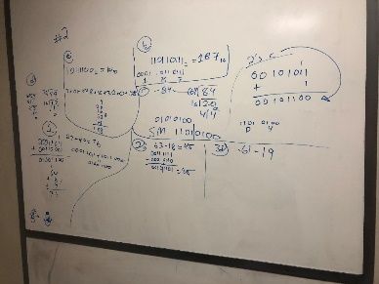

#3 Out of the 18 products presented in class, the one I am most likely going to utilize is a VPN. A VPN is short for Virtual Private Network, which really means, instead of your traffic going from your router straight to a website, your internet traffic is being sent through a different router then to your router, circumventing any restrictions on the given internet, and hides your home IP address, which is your unique ‘Internet Protocol address’, which can be traced back to where you live. By using a VPN service, such as Tunnel Bear or NordVPN, you can pay a small monthly price for online anonymity, and increased safety while browsing the internet. The way VPN works is near identical to Tor, in how both Tor and a VPN mask your IP, which creates an extra layer of security against remote hacks. VPN is a tool that should be used by everyone, alongside Tor Browser, for optimal security and possibly the safety of their personal information.
#4 =$B$3: $B$5*(1+$B$7)
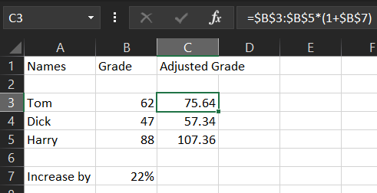
#5 B | B+ - My physical appearance was fine, I came in with a collared shirt and jeans, looked neat. I combed my hair and made sure I looked presentable. My personal issues again were anxiety, stuttering, and losing track / getting worked up. During the first speech I had more anxiety than when I gave this speech even though this speech was longer and meant more towards our grade. Whenever I speak, I always tumble over my words, that added with anxiety made me forget my train of thought multiple times. The tone of voice throughout my speech sounded very monotone, which makes the speech sound monotonous and boring. The introduction of the product is very bland and needed more enthusiasm and explanation. At one point I say the line "anonymity, so you don’t know who you are", which doesn’t make sense because anonymity has to do with yourself being unknown to other people not unknown to yourself. The way I tried to explain NoScript was utter rubbish, and I stuttered and lost train of thought, in turn explaining NoScript in a way no one would understand. One of the biggest issues with my speech was how I messed up the transition from Mozilla Firefox to Microsoft PowerPoint twice during the presentation, in which that really should not happened. The content of the presentation itself, other than some slides a bit too long and explaining the slide in like thirty seconds going straight over it. I believe that giving myself a B to B+ is justified for this being only the second speech, and it also being ten to fifteen minutes long minimum, that there should be some leeway in grading.
#6 The topics that I based my grade on are the two presentations, participation in class and behavior. The two presentations we had to complete were not the best performances ever by a long shot, but from the first presentation, to the second presentation I believe that I have increased my skill of presenting. Beginning with the first presentation, I included a lot of “umm” and “uh” statements, just to name one thing, and my second presentation contained a lot less, but still included some pauses. In class itself, I participated for each topic, always paid attention to class, sparsely used my phone in class, and my attendance is one hundred percent, and was late to class only once. Each Tuesday and Thursday, I came into class excited to learn, even for how complicated the topics were, for example binary addition and subtraction, which was my favorite topic to learn about, especially how 1’s and 2’s complement works in practice. Overall, the grade that seems most fit for the work that I have done in the class is an A-.

